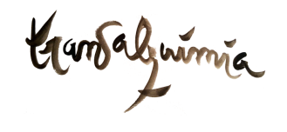

**MONTH-LONG TRAINING IN WILDERNESS RITES OF PASSAGE**

**IN THE TRADITION OF THE SCHOOL OF LOST BORDERS**

**April 30th to June 1st, 2024 - La Fradera, Spain**

**Application Form**

Name & Surname:

Age:

Country of residence:

Ethnicity:

Email:

Phone:

Please write your responses to the following questions:

1. **How did you find out about this retreat?**
2. **Please tell us something about yourself to give us a flavor of who you are.**
3. **What draws you to this training?**
4. **What is your background in this type of work as a participant and/or guide?**
5. **Please give us specific details on your last Vision Fasts as a participant** (length, with which organization, in which tradition, when, …)
6. **How do you envision using the training in your life?**

Send this form with responses by email to Diana Bacanu – [contact@transalquimia.org](mailto:contact@transalquimia.org)

**For more information:**

* Email - [contact@transalquimia.org](mailto:contact@transalquimia.org)
* Website : <https://www.transalquimia.org/spain-month-long-training>

*Your personal data will be incorporated into the Transalquimia.org files only for the purpose of being able to contact you for the Nature Connection activities that are proposed from Transalquimia. In compliance with Organic Law 15/1999 on the Protection of Personal Data, you may exercise the right of access, modification, cancellation and opposition by sending an email to info@transalquimia.org*